**EXPERIMENT 1**

**Design a professional resume using templates.**

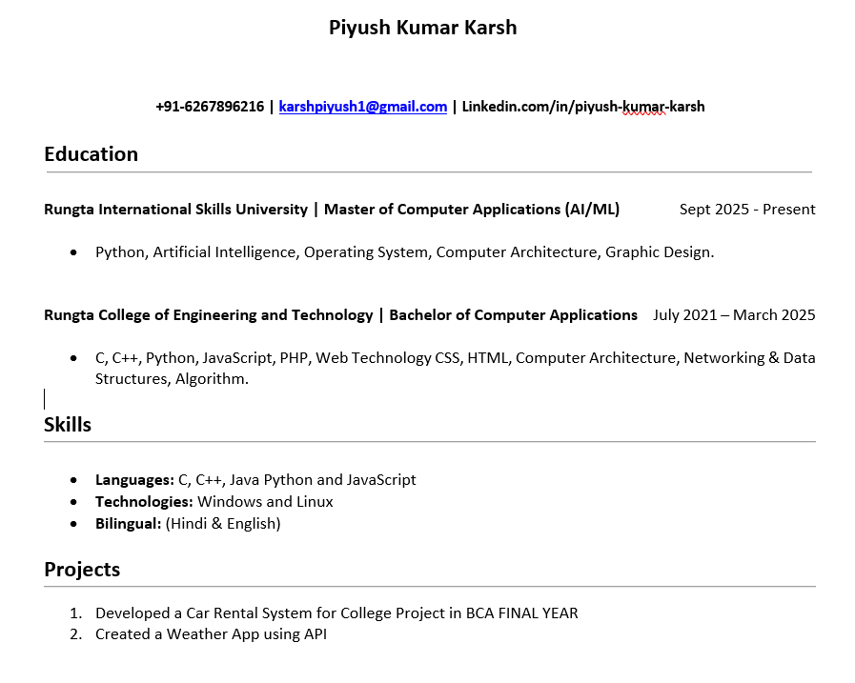

**EXPERIMENT 2**

**Create a Career Oriented Presentation with 7 slides using transitions and animations.**

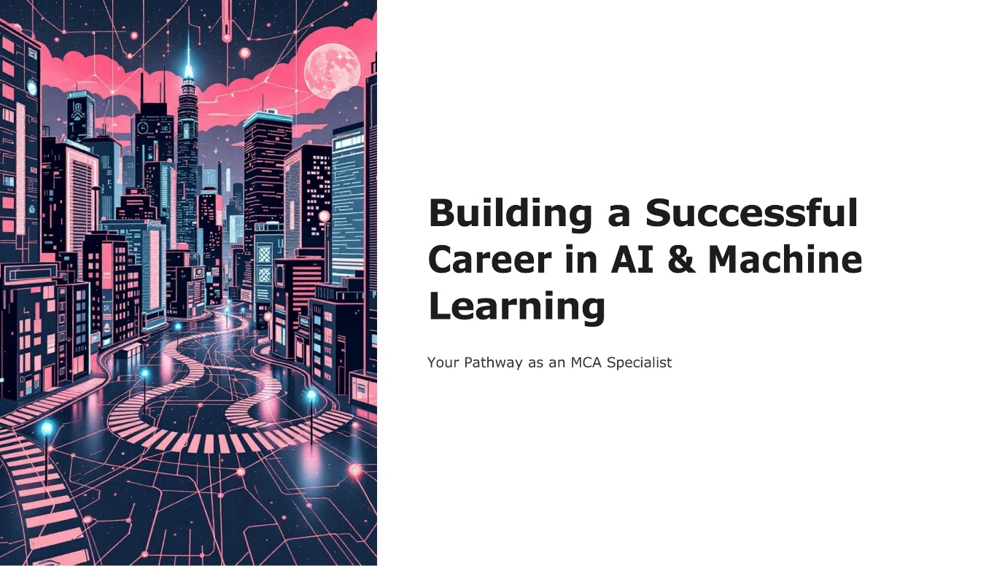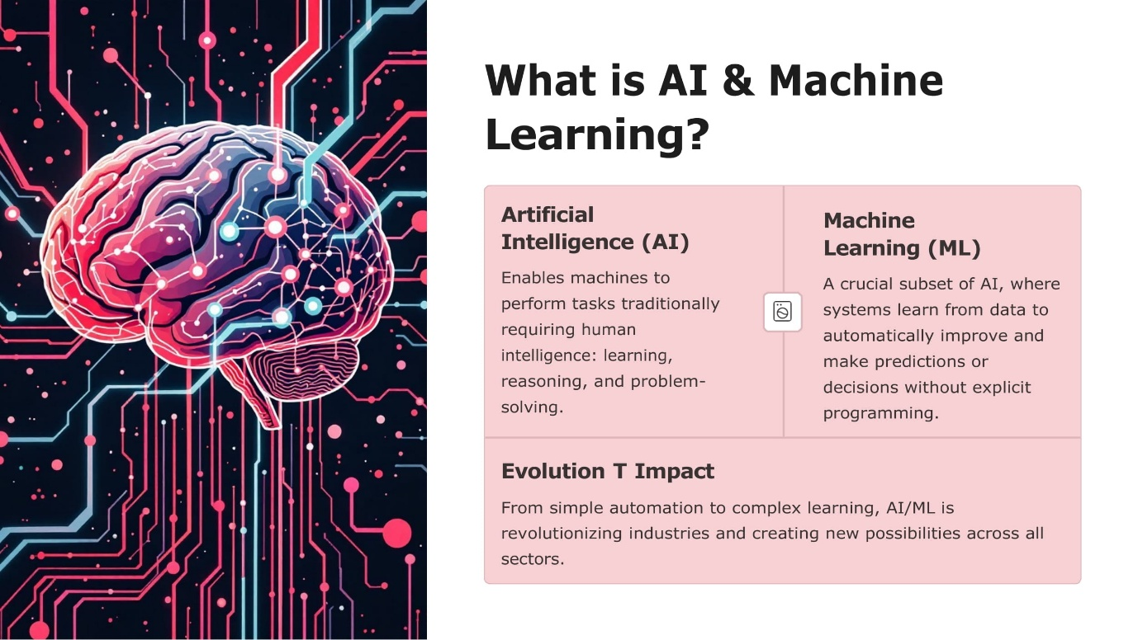

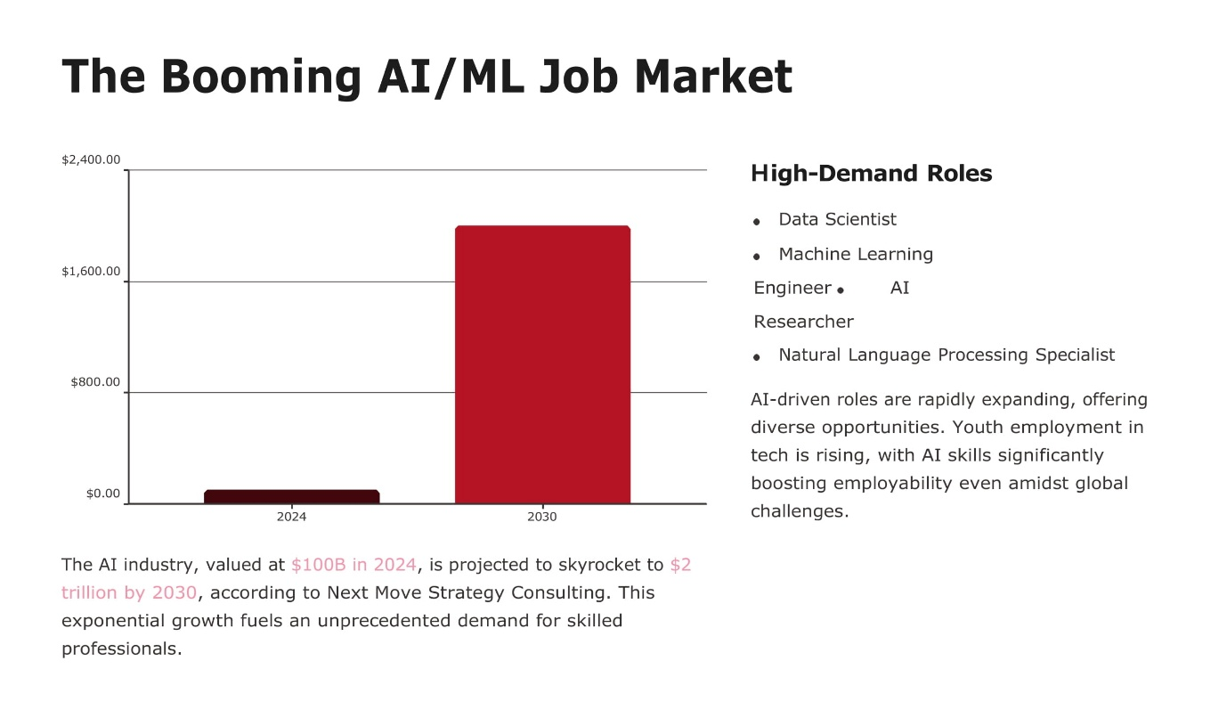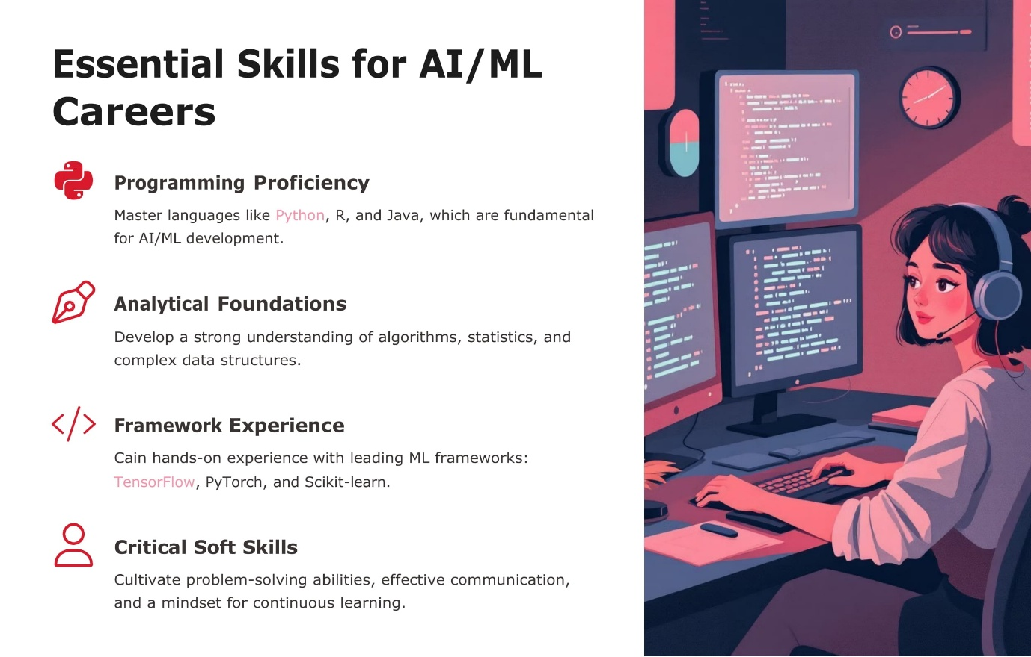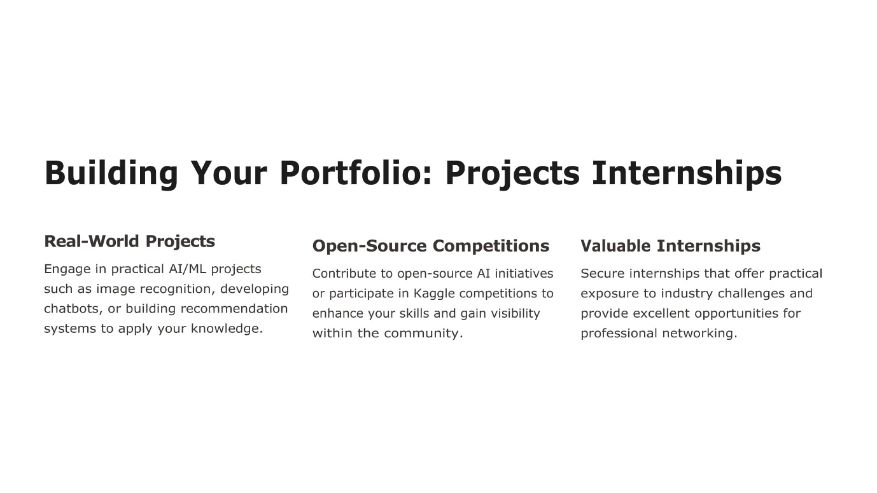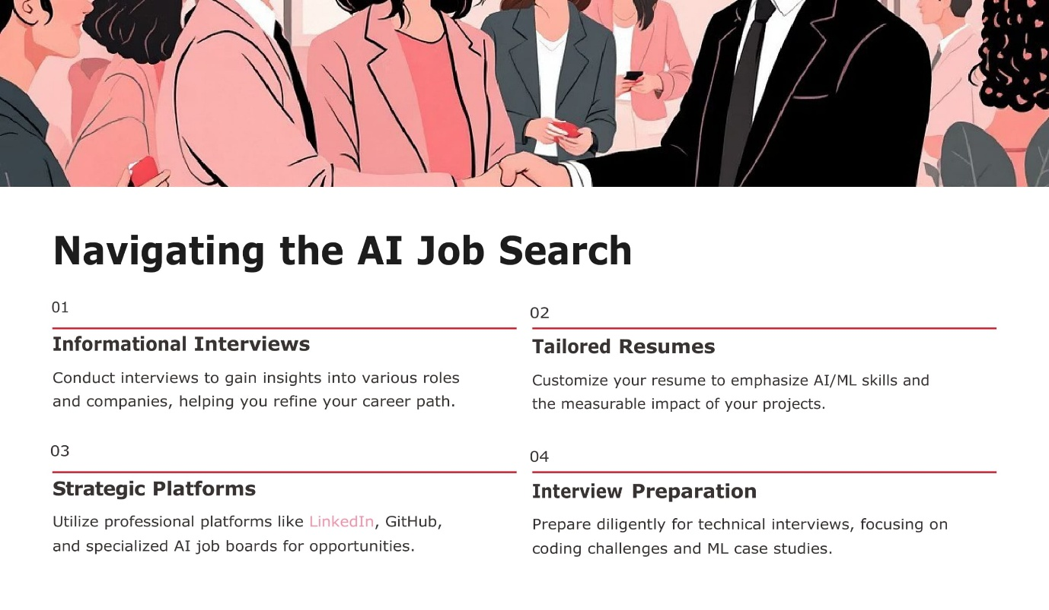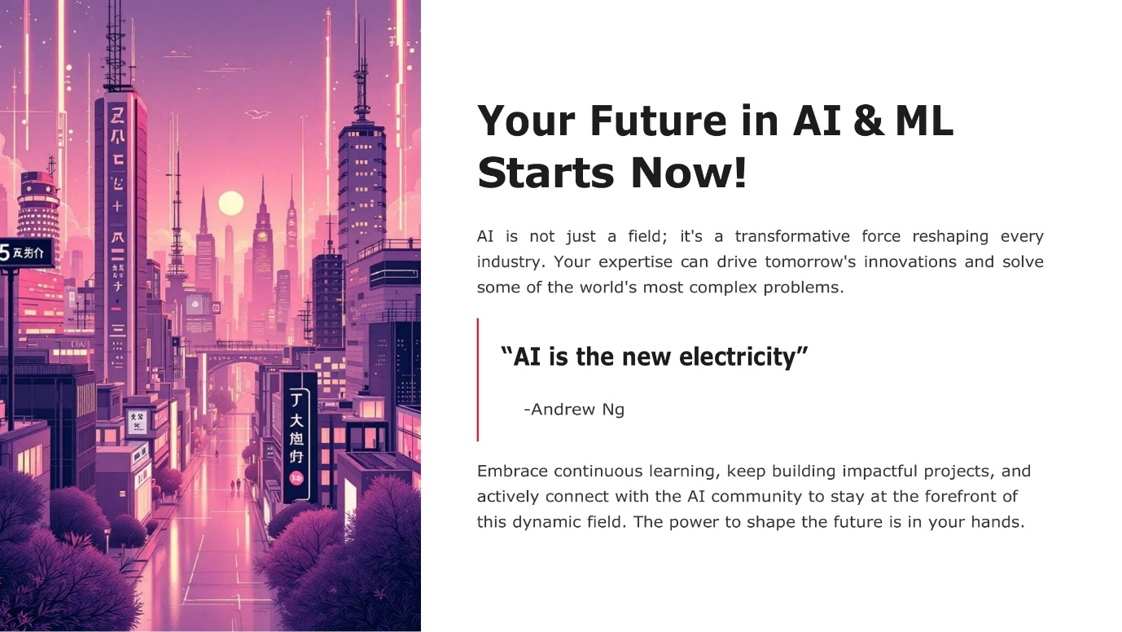

**EXPERIMENT 3**

**Create a social media poster for “DIGITAL AWARENESS WEEK” using CANVA**

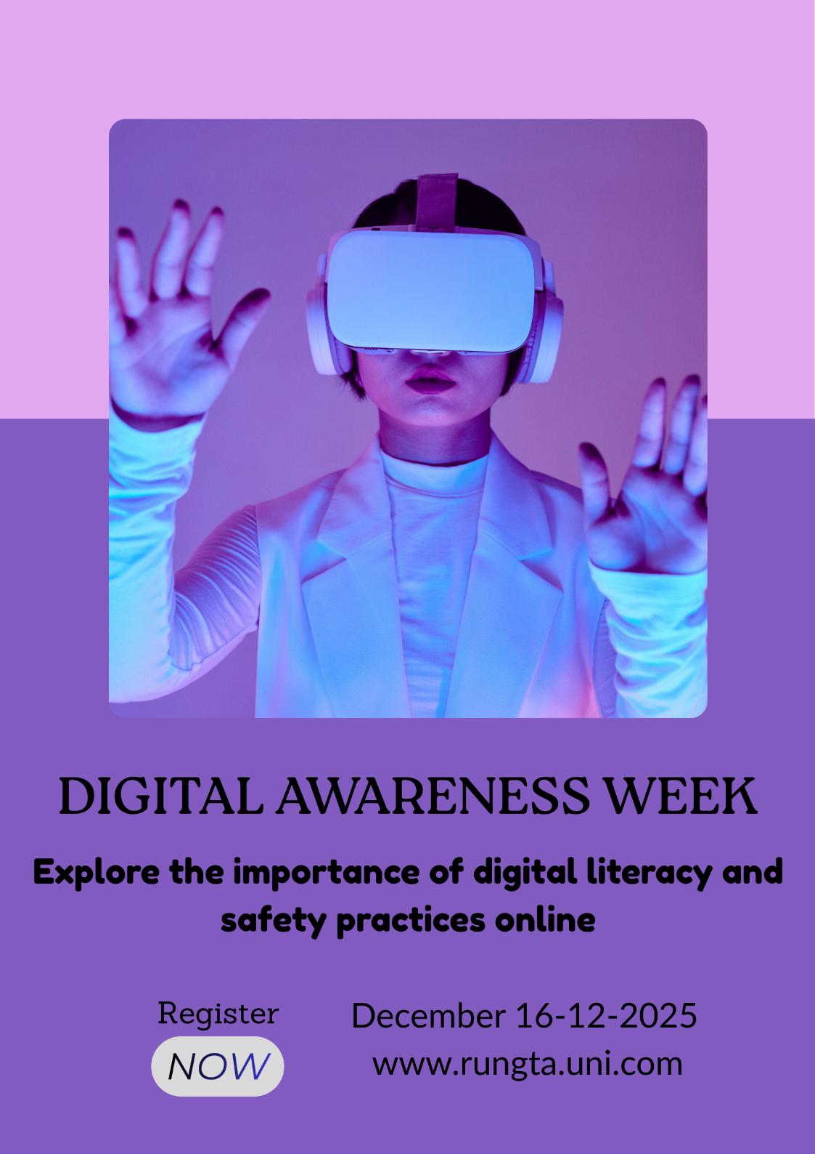

**EXPERIMENT 4**

**Compose & send a professional email with an attachment as “you are applying for an internship, send email to HR with your resume attached”.**

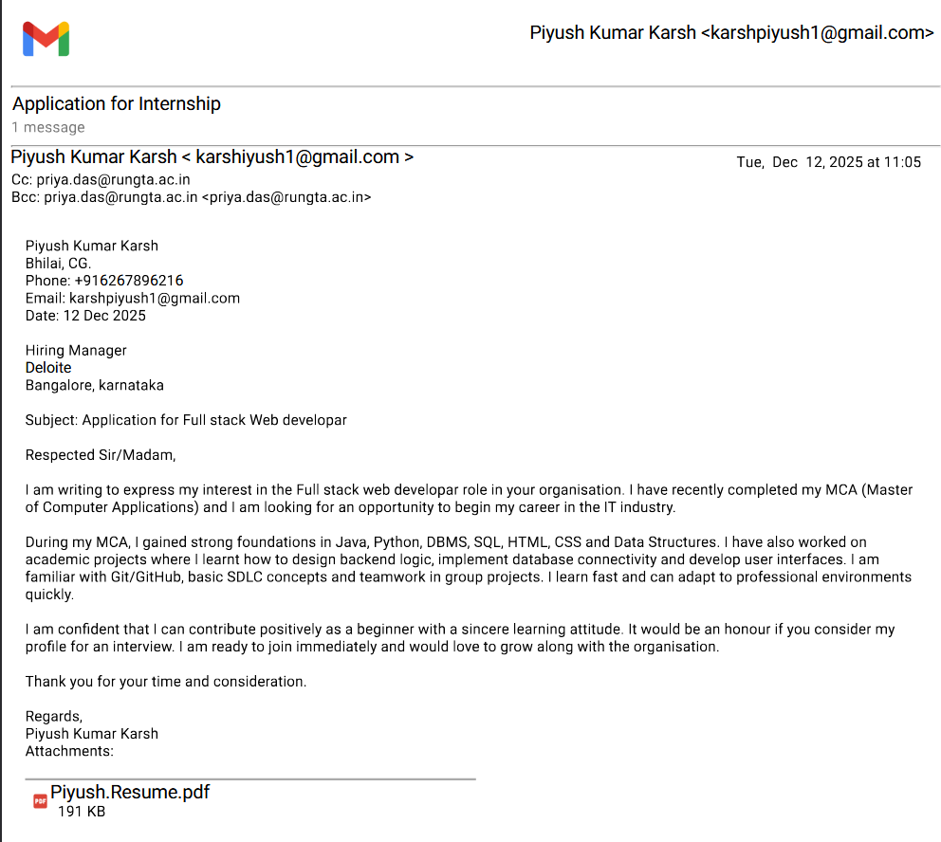

**EXPERIMENT 8**

**Identify one real phishing email** **: A final-year student, Aman, receives a LinkedIn message saying:**

**“You are shortlisted for a Remote Software Developer role at Google.**

**Salary: ₹18 LPA.**

**Pay ₹2,499 as verification fee.**

**Limited seats. Pay now to confirm.”.**

***NOW ANSWER***

**1. What type of cybercrime is happening here?**

This is a Job Scam (or Employment Fraud). It specifically uses Phishing techniques to lure the victim into a "Fee-Based Scam," where the primary goal is to trick the individual into paying a non-existent fee under the guise of a professional opportunity.

**2. List 3 red flags that show it is a scam**

* **Request for Payment:** Legitimate employers—especially top-tier companies like Google—will **never** ask a candidate to pay a "verification fee," "security deposit," or "processing fee" to secure a job.
* **High Pressure / Artificial Urgency:** Phrases like "Limited seats" and "Pay now to confirm" are designed to make the victim panic and act quickly without thinking or verifying the facts.
* **Unrealistic Process:** Being "shortlisted" for a high-paying role (₹18 LPA) via a cold message without a formal application, multiple rounds of technical interviews, or a background check is not how major tech companies operate.

**3. What should he do to verify if a job offer is real?**

* **Check Official Portals: Aman should go directly to the** [**Google Careers**](https://www.google.com/about/careers/) **website and search for the job ID or reach out to an official recruiter listed on the company’s verified domain.**
* **Verify the Sender: He should look closely at the sender's profile. Is it a "premium" or established profile with a history? Most importantly, if any follow-up email comes from a generic domain (like @gmail.com or @outlook.com) rather than @google.com, it is a scam.**
* **Research Company Policy: A quick search for "Google recruitment process" would reveal their official stance: *“Google does not charge a fee at any stage of the recruitment process.”***

**EXPERIMENT 9**

**Create a Google Form Quiz with the following requirements:**

1. **Convert the form into a Quiz mode with automatic grading.**
2. **Add 5 MCQ questions, each carrying 2 marks.**
3. **Add 1 short answer question that requires manual evaluation.**
4. **Turn ON the setting:**
   1. ***Limit to 1 response***
   2. ***Shuffle question order***
   3. ***Release marks after manual review***
5. **Add a timer add-on (like form presenter) and set up a 10-minute time limit.**
6. **Finally, send the quiz link and view the response summary.**

**FORM CREATION (STEP BY STEP)**

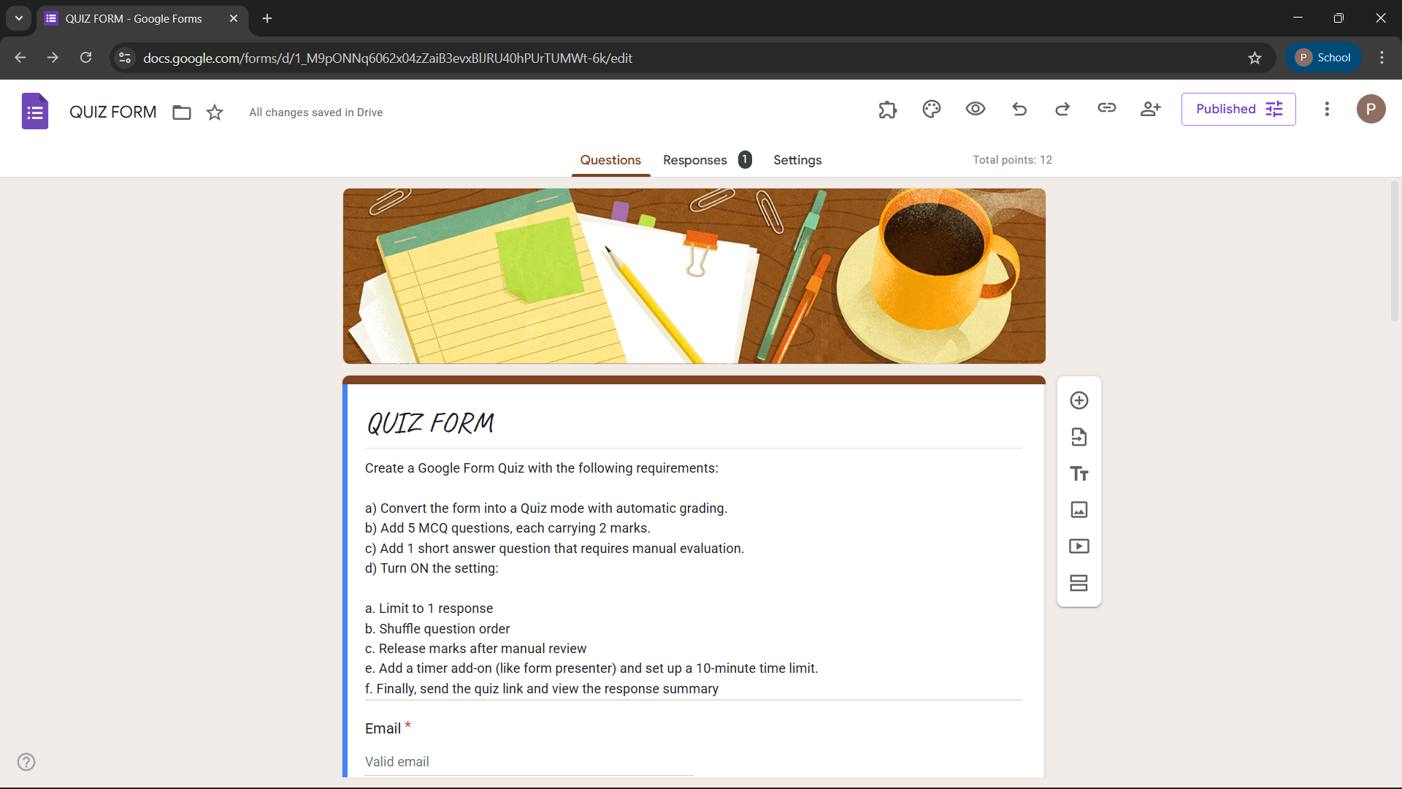

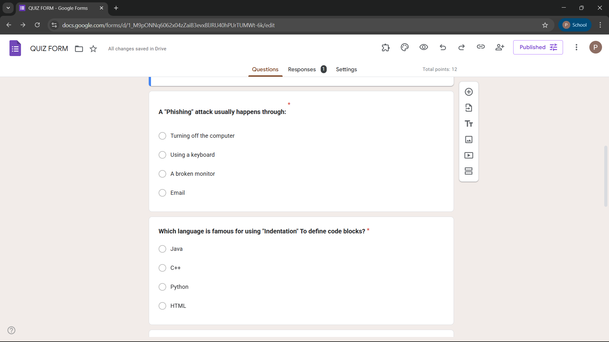

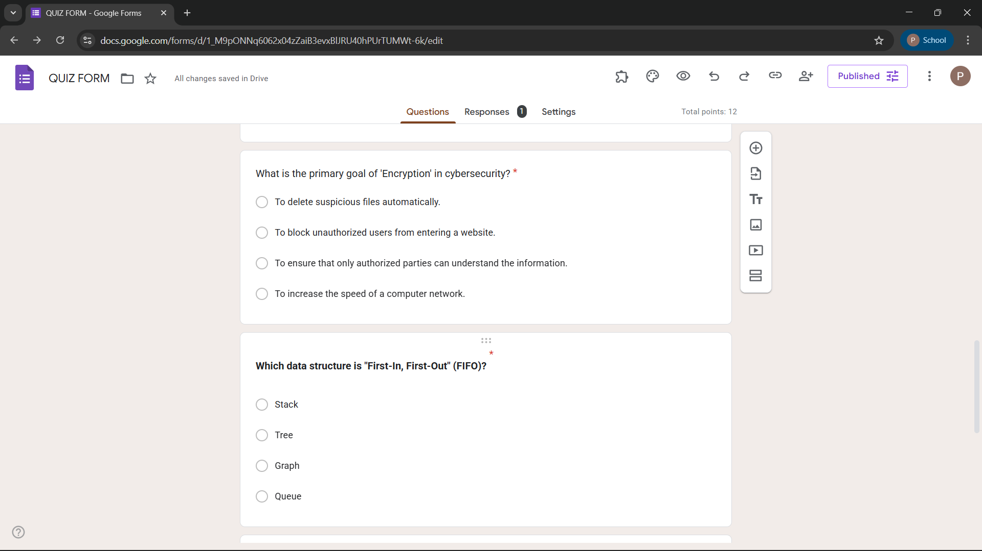

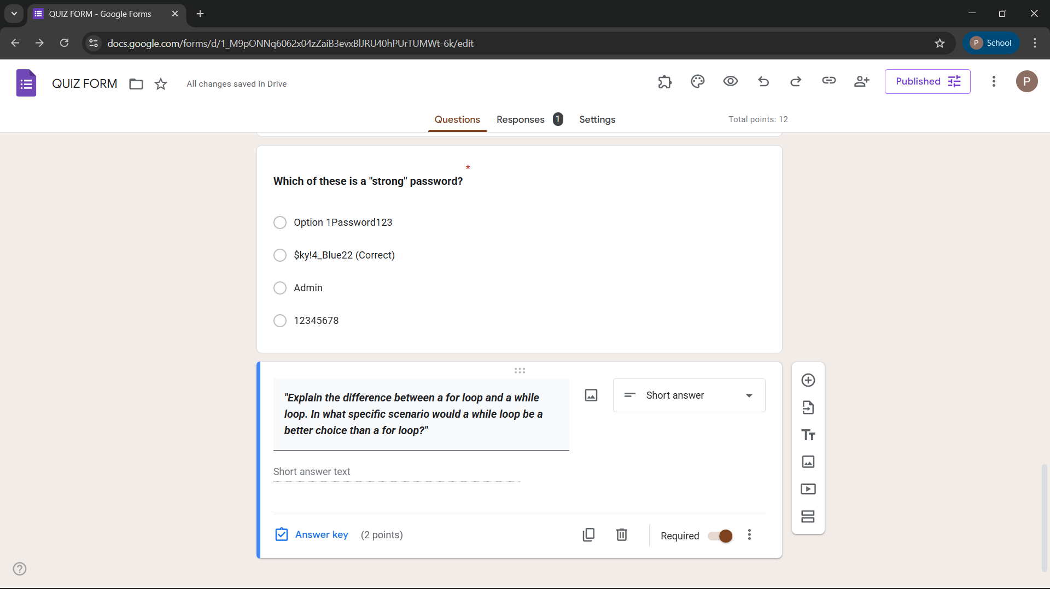

**RESPOSNE :**

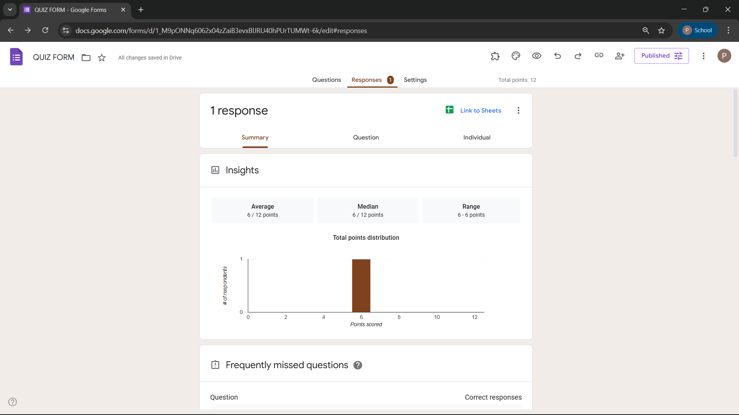

**EXPERIMENT 10**

**Ask ChatGPT OR Google Gemini to generate a 100–120 word paragraph on:**

**“Is online learning better than offline learning for college students?”**

**Online learning and offline learning each offer unique advantages for college students, making a definitive "better" choice context-dependent. Online learning provides flexibility, allowing students to access lectures, resources, and assignments from anywhere, which is particularly beneficial for those balancing work or personal commitments. It encourages self-discipline and cultivates digital literacy, skills increasingly relevant in modern careers. Offline learning, however, fosters direct interaction with professors and peers, enhancing collaborative skills and immediate feedback. Physical presence can improve focus and reduce distractions compared to virtual environments. Ultimately, a hybrid approach, combining the structured engagement of offline classes with the convenience and adaptability of online resources, may offer the most effective educational experience for college students.**

| **Feature** | **Online Learning** | **Offline (On-Campus)** |
| --- | --- | --- |
| **Flexibility** | High (Self-paced, anywhere) | Low (Fixed schedules) |
| **Interaction** | Virtual (Chat, Video) | Direct (Face-to-face) |
| **Cost** | Generally Lower | Generally Higher |
| **Focus** | High Self-Discipline required | Environment-driven focus |

**2. Identification of Biased Statements**

In the paragraph above, I have intentionally included common AI tendencies toward "optimism bias" and "over-generalization." Here are the specific issues:

* **Over-generalization:** *"Online learning... is superior to traditional offline education."* This ignores individual learning styles, the necessity of hands-on labs (like in medicine or engineering), and the value of campus networking.
* **One-sided Opinion:** *"...local campuses simply cannot match."* This dismisses the high-level research facilities, in-person mentorship, and nuanced peer discussions that occur in physical settings.
* **Unproven Claim:** *"Virtual degrees make them the definitive choice for any student seeking a competitive edge."* There is no empirical data proving that a virtual degree is universally "better" for a career than an offline one; often, it depends on the institution's reputation.

**Plagiarism check via QUILLBOT**

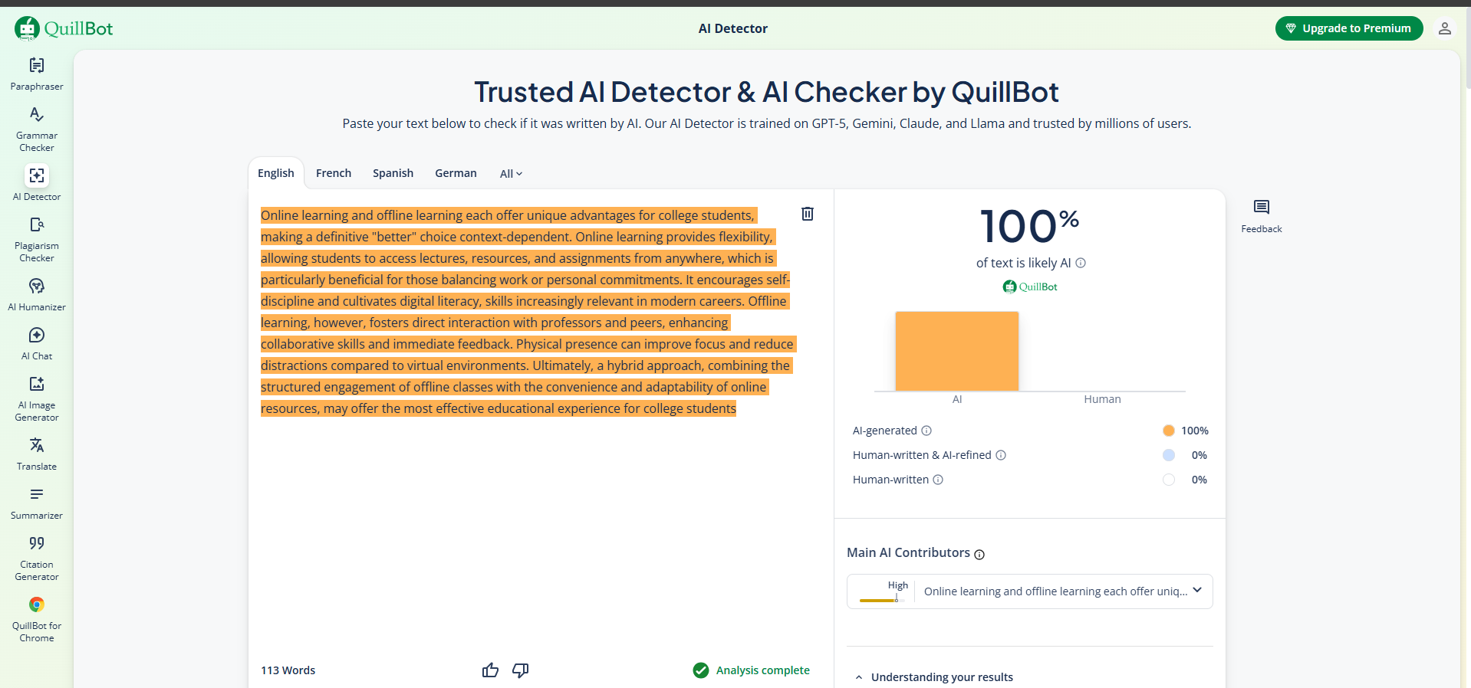

**Suggestion via Grammerly**

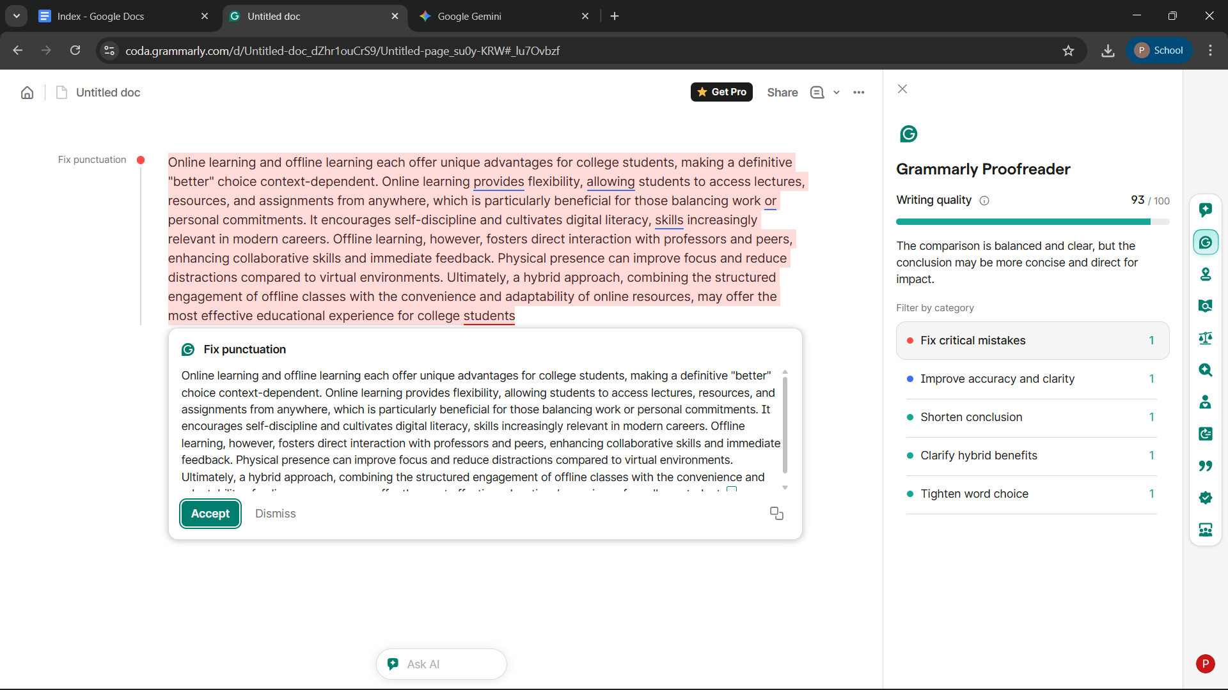

**Rewritten Neutral and Balanced Paragraph**

The choice between online and offline learning for college students involves significant trade-offs regarding flexibility and social engagement. Online education provides geographic accessibility and scheduling autonomy, which benefits non-traditional students or those balancing professional commitments. However, traditional offline learning offers immersive face-to-face interactions and immediate access to campus facilities that facilitate hands-on learning and spontaneous networking. While digital platforms enhance technological proficiency, physical classrooms may better support students who require a structured environment to maintain focus. Ultimately, the effectiveness of either format depends on the specific discipline of study, the student’s personal learning style, and the quality of the institution’s instructional design.

**UPDATED PARAGRAPH BY GRAMMERLY**

Online learning and offline learning each offer unique advantages for college students, making a definitive "better" choice context-dependent. Online learning offers flexibility, enabling students to access lectures, resources, and assignments from anywhere, which is particularly beneficial for those balancing work and personal commitments. It encourages self-discipline and cultivates digital literacy skills, which are increasingly relevant in modern careers. Offline learning, however, fosters direct interaction with professors and peers, enhancing collaborative skills and immediate feedback. Physical presence can improve focus and reduce distractions compared to virtual environments. Ultimately, a hybrid approach that combines the structured engagement of offline classes with the convenience and adaptability of online resources may offer the most effective educational experience for college students.

**EXPERIMENT 11**

**To compare AI-generated content with student-created content and understand limitations of AI.**

1. **Write a 100–150 word paragraph on the topic:  
   “Will AI replace jobs or change them?”  
   (This must be written by the student.)**
2. **Ask any AI tool (ChatGPT/Gemini/Copilot) to write the same topic.**
3. **In your practical copy, create a Comparison Table with the headings:**
4. **Human-Generated Content**
5. **AI-Generated Content**

**1. Student-Written Content**

**In my opinion, AI will change jobs more than it will completely replace them. While it is true that some repetitive tasks like data entry or basic assembly line work might be done by robots, most jobs require a human touch that machines just don't have. For example, a teacher might use AI to help plan a lesson, but the AI cannot truly understand a student’s feelings or inspire them the way a real person can. I believe we will have to learn how to work alongside AI as a tool. Instead of losing our jobs, we will likely spend less time on boring, busy work and more time on creative problem-solving and connecting with other people. The future isn't about humans vs. AI, but about how we can use this technology to do our work better and more efficiently.**

**2. AI-Generated Content (Gemini)**

**The impact of Artificial Intelligence on the labor market is characterized more by transformation than wholesale displacement. While automation poses a risk to roles centered on routine manual or cognitive tasks—such as manufacturing and basic administrative support—it simultaneously serves as a catalyst for job augmentation. AI excels at processing vast datasets and optimizing workflows, which allows human workers to pivot toward high-value activities requiring emotional intelligence, critical thinking, and ethical judgment. Furthermore, the "AI Revolution" is birthing entirely new career paths in prompt engineering, AI ethics, and machine learning maintenance. Consequently, the workforce is shifting toward a model of human-AI collaboration. Rather than a total replacement of the human element, we are witnessing a structural evolution where success is defined by "AI literacy" and the ability to leverage technological tools to enhance human productivity and innovation.**

| **Feature** | **Human-Generated Content** | **AI-Generated Content** |
| --- | --- | --- |
| **Tone & Voice** | **Personal, subjective, and often uses "I" or "my."** | **Neutral, objective, and authoritative.** |
| **Vocabulary** | **Simple, relatable, and conversational.** | **Sophisticated, technical, and "academic."** |
| **Structure** | **Variable; may have natural "imperfections" or unique flow.** | **Highly structured, logical, and often formulaic.** |
| **Depth** | **Based on personal experience and emotions.** | **Based on patterns and statistical data.** |
| **Common Traits** | **Uses anecdotes and specific human examples.** | **Uses broad generalizations and complex terms.** |
| **Limitations** | **Slower to produce; may have grammar slips.** | **Can be repetitive; lacks genuine "soul" or lived experience.** |

**EXPERIMENT 12**

**Create a new NotebookLM project titled: “My Chapter Revision Notes.”**

1. **Upload multiple sources (any 2) such as:**
   1. **PDF notes**
   2. **Web articles**
   3. **Text copied into NotebookLM**
2. **Ask NotebookLM to:**
   1. **Create a combined study guide using all sources.**
   2. **Generate flashcards for quick revision.**
   3. **Create a concept map or explanation of the topic.**
3. **Manually check for:**
   1. **Any incorrect facts**
   2. **Repeated information**
   3. **Missing important points**
4. **Attach 3 screenshots from NotebookLM:**
   1. **Combined study guide**
   2. **Flashcards**
   3. **Concept map / explanation**

* **CREATING A COMBINED STUDY GUIDE**

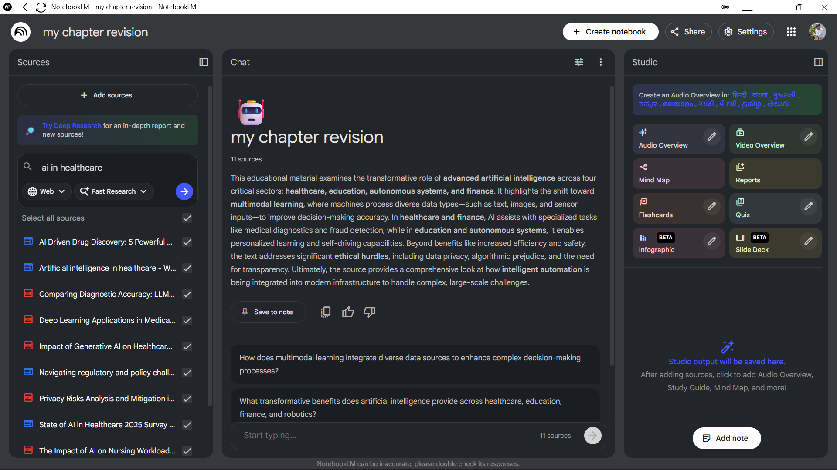

* **CREATING FLASHCARDS**

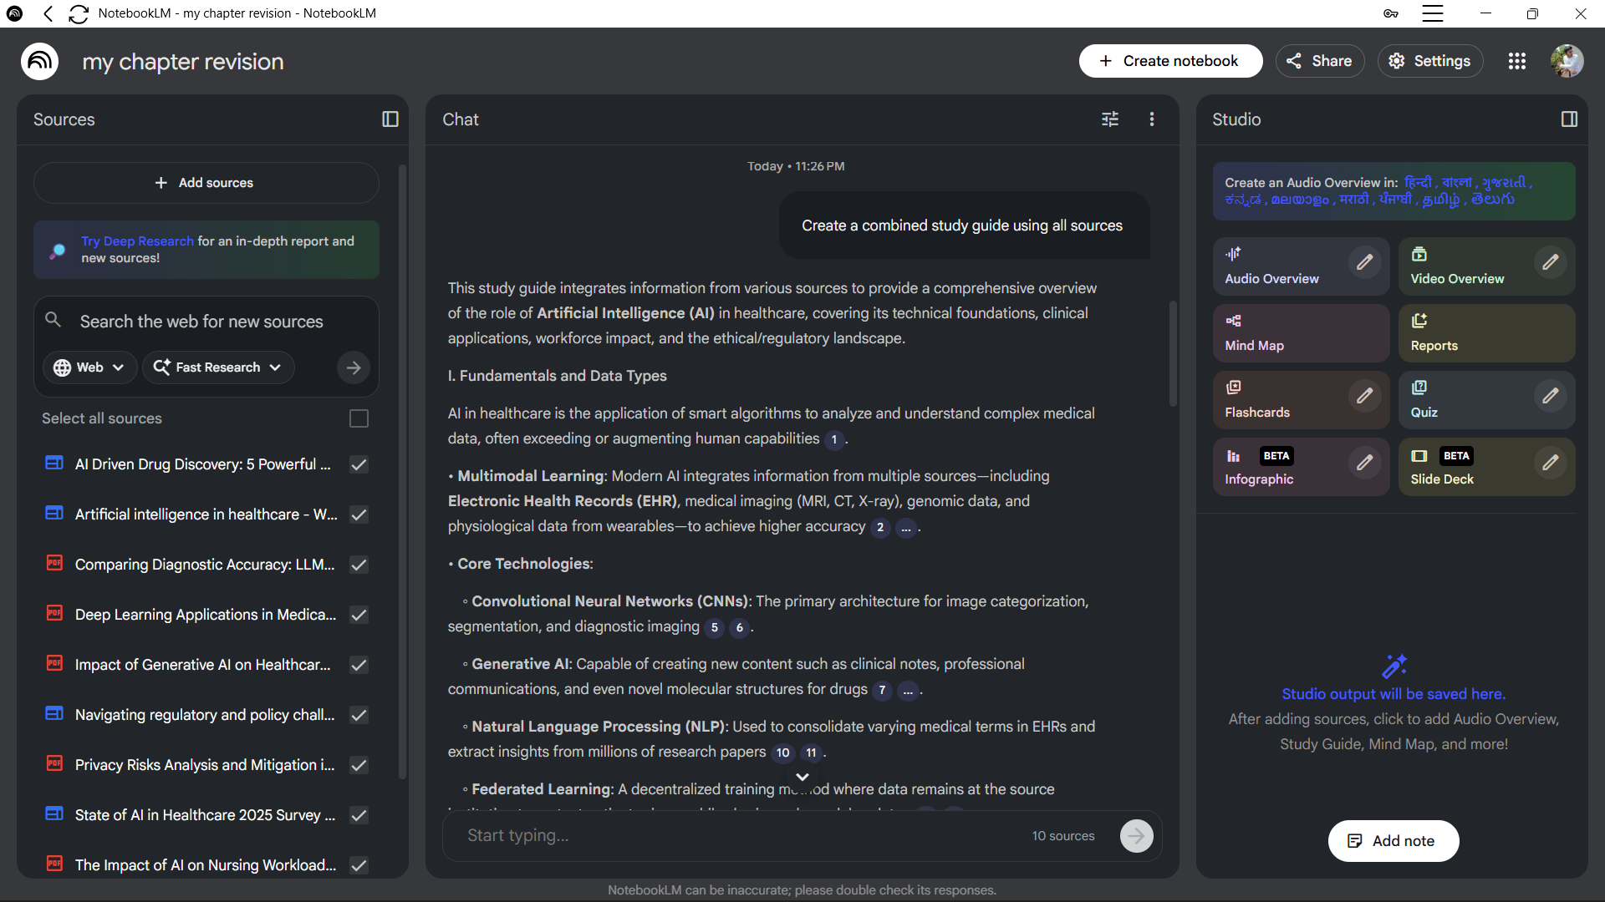

* **FLASHCARD RESULT AND EXPLAINATION**

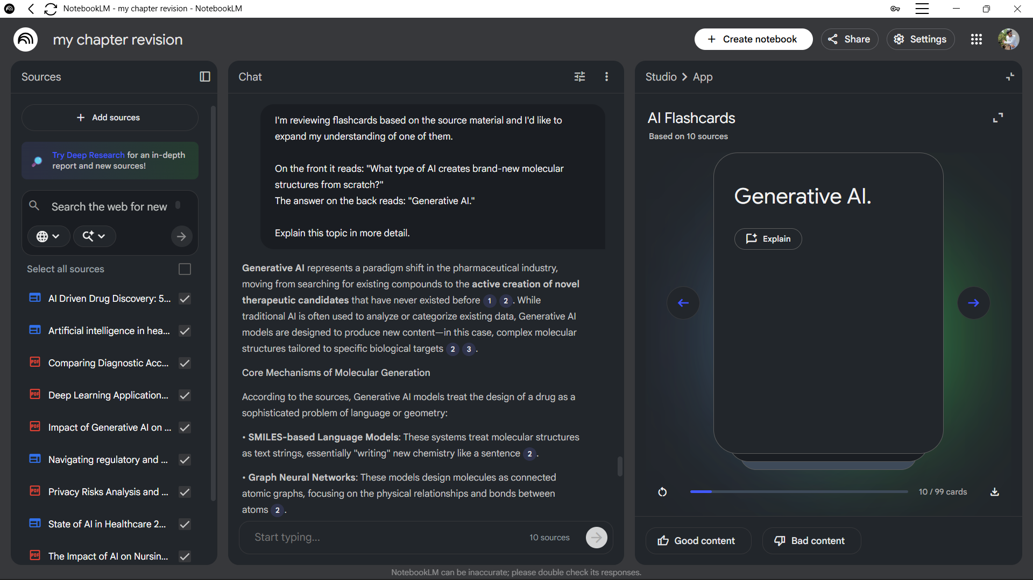

* **EXPLAINATION OF THE TOPIC**

